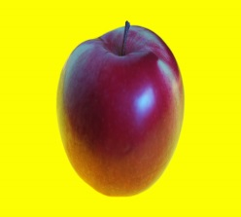MCj02159370000[1]

MCj03839720000[1]MCj04105210000[1]MCj04118860000[1]MCj04135380000[1]MCj03488650000[1]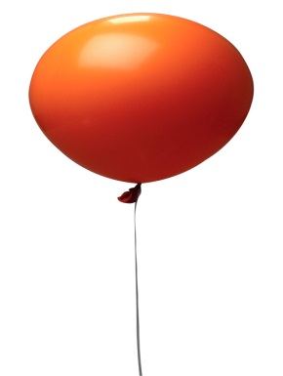MCj00899400000[1]